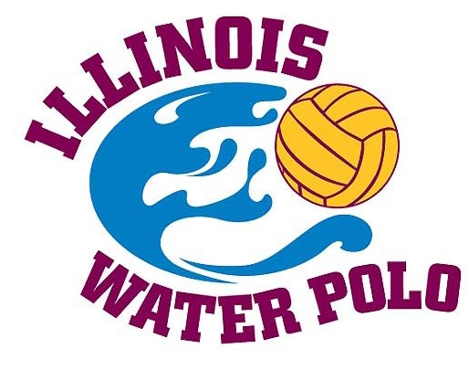
Midwest Water Polo and Aquatics Assoc.
DBA Illinois Water Polo
18771 Meadow Lane
Long Grove, IL 60060

Dear Illinois High Water Polo Fan and Supporter,

As a friend and supporter of Illinois Water Polo, I would like to invite you to be a part of a very special celebration. On Tuesday, May 24, 2005 we are going to honor Illinois High School Water Polo athletes and coaches at the IWP All State & Hall of Fame Banquet.

Water Polo in Illinois is growing fast. Believe it or not, we have 67 high schools with at least a boys or girls water polo team, many represented by both a boys and girls team. Three years ago, Illinois was one of the first states in the country to sanction water polo by its high school sports governing body, the IHSA. Many more new faces on the Illinois polo scene are discovering what we already know, water polo is an exciting, demanding, and fun sport.

The banquet attendance is targeted at 240 people, made up of the all-state athletes with their parents, coaches, Illinois Hall of Fame inductees, referees, and the many friends of the sport. It’s an ideal time to honor individual or team achievement or for a company to connect with this elite crowd.

We have attached the list of sponsorship opportunities for this year’s banner event with details of each sponsorship levels and the benefits to you as a sponsor. We hope you will join us in helping to continue to promote the development and awareness of water polo in Illinois.

Thank you for your support and consideration of sponsorship of our high school water polo players.

Midwest Water Polo and Aquatics Association, doing business as Illinois Water Polo is a 501(c)(3) tax exempt organization and your generous support is tax deductible. Please feel free to contact myself at 312-371-7895 (email gkapecki@espreemag.com) or my fellow committee member Pat Peterson at 847-566-0408 (email: ppete127@comcast.net) and as always you may go to the Illinois Water Polo website at www.illpolo.com for additional information as well.

Sincerely,

Garrin Kapecki
Chairman, Illinois Water Polo

Illinois Water Polo
2005 All-State Banquet Sponsorship Opportunities

Banquet Goal: To celebrate the achievements of Illinois High School Water Polo.

Fundraising Goal: To underwrite the opportunity to honor the achievements of the outstanding young men and women high school water polo players in the state of Illinois. All proceeds are dedicated to the promotion and development of the sport of water polo in the state of Illinois at the age group and high school levels.

Sponsorship Opportunities:

Name of Level | Sponsorship Amount | Benefits
Event Sponsor | $5,000 | 4 dinner tickets, listed on front of program as event sponsor, one banner to be displayed at banquet supplied by sponsor, invitations/flyer with sponsor name/logo, listed as major sponsor on website with link to sponsors website, 2 full page ad (center) in program, provide for product giveaway to promote your organization at the banquet, brand presence at each table.
Award Sponsor | $1,250 Boys Award Sponsor  $1250 Girls Award Sponsor | 4 dinner tickets, one banner supplied by sponsor to be displayed at banquet, Acknowledgement of sponsorship on Award page in program, invitation/flyer includes sponsor name/logo, listed on website, full page ad, presenter of Awards at banquet
Printing Sponsor | $1,000 | 4 dinner tickets, Back page of program, recognition on invitation/flyer, listed on website
Gold Sponsor | $500 | 4 dinner tickets, listing in program * as a Gold Sponsor, full page ad if requested.
Silver Sponsor | $300 | 2 dinner tickets, listing in program* as a Silver Sponsor, full page ad if requested.
Bronze Sponsor | $150 | 2 dinner tickets, listing in program * as a Bronze Sponsor, full page ad if requested.
Banquet Table Sponsor | $300 | 10 tickets and reserved table with your company logo, recognition in banquet program
One Half Page Ad | $75 | Advertisement of your choice in banquet program
- program printing deadline is ________________________

Your support goes to helping promote and create expanded competitive opportunities for Illinois Water Polo Athletes and is very much appreciated.

Illinois Water Polo
2005 All-State Banquet Sponsorship Opportunities Form

Yes, I’d like to support Illinois Water Polo and be a sponsor at the following level:
- Event Sponsor
- Award Sponsor
- Print Sponsor
- Gold Sponsor
- Silver Sponsor
- Bronze Sponsor
- Table Sponsor
- Advertisement (Half Page)

- I cannot be a sponsor but would like to donate the following amount to support Illinois Water Polo and the 2005 All-State Banquet_____________________________________

Name:____________________________________________________
Name of Company:__________________________________________
Address:___________________________________________________
Phone Number:________________________________(where you can be reached to finalize any advertising etc. to be done for banquet)
Name of Water Polo Player(s) you are affiliated with and would like to be recognized__________________________________________________
(Please feel free to include a business card with this form if desired)

Thank you for your support and consideration of sponsorship of our Illinois high school water polo players. Midwest Water Polo and Aquatics Association, doing business as Illinois Water Polo is a 501(c)(3) tax exempt organization and your generous support is tax deductible.

Please return this form and a check made payable to Illinois Water Polo to MWPAA – Illinois Water Polo, c/o Patricia Peterson, 530 Salceda Drive, Mundelein, IL 60060. Other correspondence can be sent to Illinois Water Polo at Midwest Water Polo and Aquatics Assoc. DBA Illinois Water Polo, 18771 Meadow Lane, Long Grove, IL 60060. Advertisement and logos are due May 5, 2005. We can accept many different file types including Illustrator or Photoshop files would be best quality (.ai or .psd), but .jpegs would work as well. Files can be emailed to Brett Hatcher at ubberstubby@aol.com .

Please keep an eye on the Illinois Water Polo website for the latest information on our high school players and their teams! www.illpolo.com

